UNIVERSITY OF RWANDA

AFRICAN CENTER OF EXCELLENCE IN IoT

MODULE: SMART SENSORS AND ACTUATORS

GROUP MEMBERS:

1.ANGEL GABRIEL MEELA

2.JEAN BAPTISTE HABANAKIZE

3.DENYSE NYIRAMUGISHA

TOPIC: SMART PET FEEDING

DESCRIPTION

Do you own a pet? Has he or she ever disturbed you early in the morning to beg you for food? Or maybe you couldn't get home quite on time, so you had to make your pet wait till you get home to feed them? Well, now we have came up with an idea to build an automated pet feeder that can be controlled away from home.

COMPONENTS USED

* Servo Motor x 1
* Nodemcu x 1
* USB Cable x 1
* Jumper Wires
* Breadboard x 1
* Water bottle x 1

SOFTWARE USED

* Arduino IDE
* ARDUINO Libraries
* MQTTBox

CIRCUIT CONNECTION

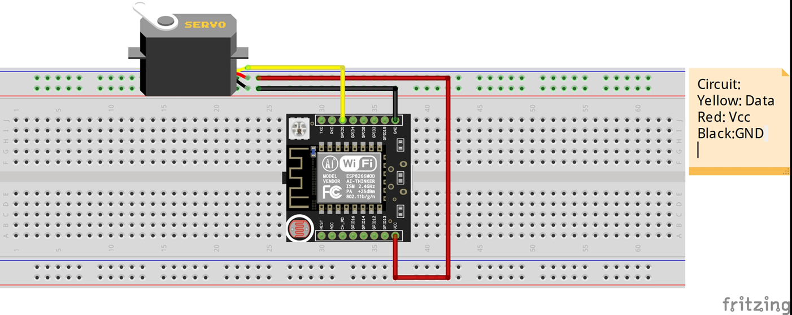

[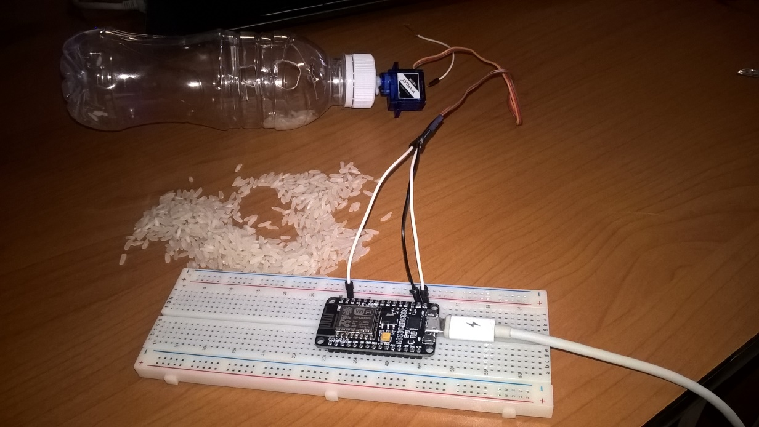](https://drive.google.com/file/d/1B6tFT-Q3RzAfrLfeJC503kKKmaeWEJPE/view?usp=sharing)

PROGRAM CODE ( Click on the above image to access the code)